Acoustic Descriptions of Korean Stops
Dan Jinguji
Ling 453, Autumn 2006

Introduction and Background
It is common to see a two-way distinction for homorganic stops in language. Often this is characterized as “voiced” and “unvoiced” variants of the stop. Alternately, these have been described using the terms: “lenis” and “fortis”, or “aspirated” and “unaspirated”. Among the major languages of the world, Korean is unique in possessing a three-way phonemic contrast for homorganic stops. Specifically, the bilabial, alveolar, and velar stops exhibit this three-fold distinction. Similarly, the palatal affricate also exhibits the same three-fold phonemic contrast.
These stops are commonly characterized using the labels, “lenis”, “fortis”, and “aspirated”, or “lax”, “tense”, and “aspirated”. Within the native orthography, Hangeul, the fortis and aspirated stops are indicated as variants of the lenis stops. The fortis stops are indicated by doubling the glyph for the lenis stop. The aspirated stop is typically described as the lenis stop plus an additional horizontal stroke, indicating the aspiration.
 | Lenis | Fortis | Aspirated
Bilabial | ㅂ | ㅃ | ㅍ
Alveolar | ㄷ | ㄸ | ㅌ
Palatal | ㅈ | ㅉ | ㅊ
Velar | ㄱ | ㄲ | ㅋ
The naming of the consonants are worthy of comment here. In general, the names are created from the pronunciation of the consonant as an onset and as a coda. The traditional names date from 1527. The South Korean names for the fortis consonants are created from the name of the lenis consonant with the prefix “ssang” (쌍) “double”, describing the appearance of the glyph. The North Korean names for the fortis consonants use the prefix “doen” (된) “strong”, describing the articulation of the consonant, mirror the fortis designation.
There has been relatively extensive research done on the descriptions of these consonants to describe the differences in terms of acoustics and physiology.
Lisker and Abramson (1970) showed that mean VOT varies significantly between the three stops types in word-initial positions. However, in their study, the range of values overlap, so they cannot be used as a sole means to distinguish between them. Their analysis showed the fortis stop had the shortest VOT in word-initial position, followed by the lenis stop, with the aspirated stop having the longest VOT in word-initial position. This study looked also at these stops in non-initial positions as well. In non-initial positions, the same relationships appear, but the overlap between the lenis and fortis stops is greater, providing less distinguishing power.
Han and Weitzman (1970) showed that f0 could also help distinguish between these varieties of stops. The vowels following fortis and aspirated stops are marked by a raised f0 value. Needless to say, this distinction alone would not be sufficient to distinguish between these stops, since both the fortis and aspirated stops are followed by vowels with raised f0.
In a more comprehensive, recent study, Cho et al (2002) examined two dialects of Korean, Seoul and Cheju. The Seoul dialect, as the speech of the metropolitan capitol of the nation, is designated as the standard dialect. It is also the most dynamic dialect of Korean in regard to language change. The Cheju dialect, on the other hand, is geographically isolated from the rest of the nation. It is also the most conservative dialect of Korean, preserving distinctions that have been lost in other dialects of Korean over a century ago.
Cho et al. examined both acoustic and articulatory features of the stops. Their findings confirmed those of the previous researchers. They measured other acoustic features, focusing on the characteristics of the following vowel. Additionally, they measured aerodynamic mechanisms for these three stop types. It should be noted that the word-list used in this study examined a single vowel context, for Seoul Korean. The grammatical context for the test word was the citation form of various common verbs; specifically, the test word was /_ata/ (with the exception of the “lenis” /t/ which does not appear in this context. They used /talta/ instead.) The Cheju words were similarly structured, as citation forms of verbs, the consonant of interest appearing word-initially and followed by the mid-low vowel /a/.
Cho also mentions studies in which stop duration as an acoustically distinctive feature for the Korean stops (Han 1996). Cho found that this insufficient since there was little distinction between fortis and aspirated stops in duration of closure.
In a similar cross-dialect study, Choi (2002) looked at the Chonnam and Seoul dialects of Korean. In this study, Choi found that these dialects both can use VOT and f0 as markers for the different forms of the stops. In Choi’s analysis, the Chonnam dialect shows more distinction 3-way distinction for VOT and 2-way for f0, where the Seoul dialect shows a 2-way distinction for VOT and a 3-way one for f0. In this study, the test words were nonsense using the form /_apa/ (alternately, /_aba/, since the lenis bilabial stop will be voiced in an intervocalic position.)

Procedures
This is a preliminary study to describe the three-way stop contrast in Korean in preparation for a L2 acquisition / perception experiment.
Building on the previous work, this study will examine VOT and f0 as a primary means to discriminate the three varieties of stop.
This study will expand on some of the more recent work by considering these stops not only in word- / phrase- initial positions, but also in intervocalic positions. Additionally, this study will examine these stops within three different vocalic contexts, namely /a/, /i/, and /o/. Specifically, the stops appear word initially and between a pair of each of the three vowels. For the word list, see Appendix A.
The word list is relatively complete. There are some issues, however. Several of the fortis and aspirated stops do not seem to be available within all of these intervocalic contexts. For these stops, consonant clusters that are typically described in phonological descriptions of Korean as equivalents were used. Specifically, the unavailable aspirated stops were replaced by the lenis stop followed by /h/. Similarly, for the fortis stops, the geminate lenis stop was used. Even with this work around, the fortis palatal affricate / stop could not be found.
These 71 tokens (3 kinds of stops, 3 vowels, 4 places of articulation, 2 positions, less one missing combination) were presented along with 29 distracter words to yield 100 tokens. The list of test words was presented in random order four times. The distracter words were placed such that the first four tokens and the last five tokens in each column of text were drawn from the distracter lists. These distracter words were structurally verisimilar to the test words, primarily CVCV structure, primarily bisyllabic, though they used a broader range of consonants and vowels.
The tokens and distracter words were put into the carrier phrase 다시 한번 ___(이)라고 하세요. /taʃi hanbɔn ___ (i)raɡo haseyo/ “Please say ___ again.” The morphophonology of Korean has the empathetic vowel /i/ before the complementizer /-raɡo/ when the quoted utterance has a coda. So, each of the syllables will have a CV structure for the consonant-vowel in question, even if the word in isolation would demonstrate a coda.
The subject for this pilot project was a male in his mid-twenties, a native of Seoul, Korea. The recording was done in a reduced-sound booth using a stationary microphone, recording to Sound Studio on the Macintosh, running OS X. The recording is 16-bit with a sampling rate of 44,100 Hz. This was then down-sampled to 22,050 for analysis. Analysis used Praat (Bergsma, 2006), viewing a 0.35 slice of the data within a window with width 1200 pixels. Measurements were taken based on the wave form, with the spectrogram used to help recognize transitions. The view range for the spectrogram was 0 – 6,000 Hz, a window length of 0.005 s, dynamic range of 60.0 dB. Formant tracking was enabled, with settings: maximum formant 5,550.0 Hz, 5.0 formants, window length 0.025 s, dynamic range 30.0.

Discussion
The general form of the data collected conforms to the published results. There are, however, some confounding issues.
The 400-token list was a bit too long. There was clearly some speaker fatigue by the end of the recording as evidenced by creaky voicing and a noticeable increase in the rate of speech.
There is vowel devoicing in certain circumstances in Korean (Mo, 2005). For some of the consonant-vowel combinations, every instance had a fully devoiced vowel. Just as problematic, there were a good number of cases of partially devoiced vowels in the data. The VOT measurement started with the release burst till the beginning of the periodic wave form, where it exists. Clearly, complete devoicing makes f0 measurement extremely problematic.
As for Lisker and Abramson (1970), this data shows for word-initial stops the shortest VOT occurs for fortis stops, the longest for the aspirated stops, with the lenis stops falling between. This is probably the clearest looking at the data for /p/ since it shows no devoicing or partial devoicing, Table 1. This data is particularly “pretty” since the range of values are completely disjoint, no overlap.
Table 1: VOT values for word-initial /p/
VOT values for /pa/, /p*a/, /pʰa/
lenis 0.0738 0.0475 0.0287 0.0523
fortis 0.0119 0.0128 0.0109 0.0110
aspirated 0.1035 0.1063 0.1138 0.1087
VOT values for /po/, /p*o/, /pʰo/
lenis 0.0534 0.0677 0.0662 0.0738
fortis 0.0110 0.0181 0.0159 0.0110
aspirated 0.1035 0.0950 0.0792 0.0777
VOT values for /pi/, /p*i/, /pʰi/
lenis 0.0533 0.0569 0.0634 0.0413
fortis 0.0159 0.0110 0.0269 0.0169
aspirated 0.1230 0.0894 0.0689 0.0774
As noted, partial devoicing of consonants appeared in several data points. In general, vowel devoicing has been noted with high consonants, most frequently with aspirated stops and sporadically after lenis stops (Mo, 2005). However, we have something that appears like partially devoiced vowels with the mid-low vowel following the lenis velar stop, /ka/, Figure 1.
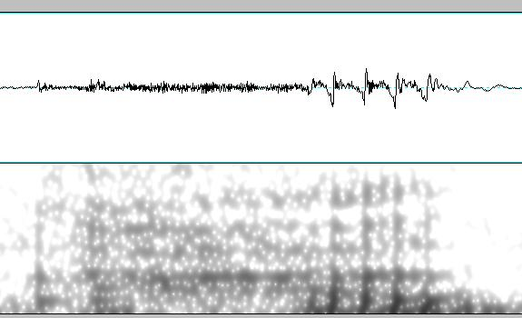
Figure 1: Wave form and spectrum for /ka/
This long frication leads to “atypically” long VOT measures for the lenis stop. This data is shown in Table 2.
Table 2: VOT values for word-initial /ka/
VOT values for /ka/, /k*a/, /kʰa/
lenis 00.1004 0.1069 0.0941 0.0993
fortis 00.0333 0.0346 0.0279 0.0316
aspirated 00.0571 0.0906 0.0816 0.1037
In fact, you will notice that the mean VOT value for the “lenis” /ka/ is longer than the mean VOT value for the “aspirated” /k^{h}a/. This would cast doubt on the primacy of VOT as the means to distinguish between these stops word-initially.
One might hypothesize sensitivity to the vowel-like character of the frication. This seems unlikely as the mechanism used to distinguish the lenis and aspirated stops since one can observe similar vowel like formants with the aspirated stop, /k^{h}a/, Figure 2.
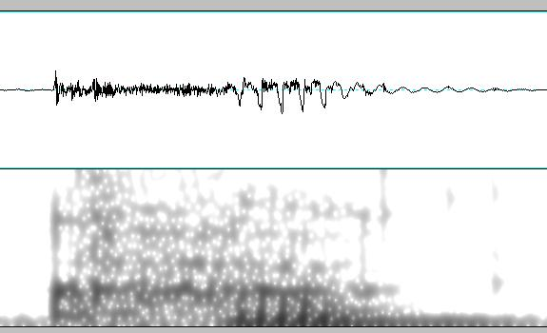
Figure 2: Wave form and spectrum for /k^{h}a/
While the formant-like structure is not as distinct in the case of the aspirated stop, the general features of the frication seem quite similar. In fact, from an articulartory point of view, this would be expected, since the vocal resonators must be moving into position for the vowel.
Han and Weitzman (1970) saw significant f0 differences for fortis and aspirated stops when compared with their lenis counterparts. The current data displays the same pattern for f0 for word-initial stops: low f0 for vowels following lenis consonants, high f0 for vowels following fortis and aspirated consonants, Table 3.
Table 3: f0 values for word-initial /a/
f0 values for /ka/, /k*a/, /kʰa/
lenis 93.39 109.12 93.76 108.10
fortis 137.70 120.91 123.57 127.84
aspirated 142.60 134.63 131.25 138.29
f0 values for /ta/, /t*a/, /tʰa/
lenis 99.96 103.09 99.78 103.19
fortis 131.87 123.35 132.95 122.34
aspirated 123.68 133.92 107.73 129.73
f0 values for /pa/, /p*a/, /pʰa/
lenis 94.37 99.09 104.37 108.47
fortis 132.12 127.96 134.80 119.17
aspirated 130.71 146.80 119.60 121.36
f0 values for /ʧa/, /ʧ*a/, /ʧʰa/
lenis 100.95 100.01 103.89 97.24
fortis 132.92 126.18 108.30 126.10
aspirated 144.70 135.44 119.32 116.34
Notice the combination of VOT and f0 could be used to distinguish between the three-way contrast for these stops. This is similar to the situation described by Choi (2002) where VOT and f0 display alternately 2- and 3- contrasts within the Seoul and Chonnam dialects.
An interesting feature of the f0 measurements was the changes in f0 from the initiation of periodicity to vowel steady state. The determination of the initial f0 measurements was a bit troublesome. Early in the voiced vocalic portion, the duration of a cycle may be somewhat unstable. Therefore, the values calculated by Praat may be somewhat questionable. The data presented below used values that were verified by hand, made by measuring the duration of two cycles of periodicity and averaging over the two.
Table 4: Delta f0 for word-initial /a/
Change in f0 values for /ka/, /k*a/, /kʰa/
lenis 2.13 -0.46 -6.28 -1.71
fortis 6.40 22.77 17.26 -1.98
aspirated -3.31 -12.64 -5.87 -10.54
Change in f0 values for /ta/, /t*a/, /tʰa/
lenis -23.76 -3.39 -5.37 -4.34
fortis -3.64 9.13 1.41 6.16
aspirated -10.46 -2.01 -12.18 -4.17
Change in f0 values for /pa/, /p*a/, /pʰa/
lenis -11.85 -19.87 -11.02 -11.80
fortis 1.39 13.74 6.93 2.33
aspirated -5.28 -8.76 0.24 3.58
Change in f0 values for /ʧa/, /ʧ*a/, /ʧʰa/
lenis -21.49 -8.21 -10.53 -7.02
fortis -4.26 -0.35 14.65 13.47
aspirated -8.71 -14.34 -1.00 0.36
What is interesting about these values is the distribution of positive values. They primarily appear for the fortis stops. That is that the f0 increases for these. So, the f0 values rise to the high f0 values for fortis stops. By contrast, notice the negative delta values for the aspirated stops. Thus, the f0 values fall to the high f0 value for the aspirated stops.
The intervocalic consonants displayed different characteristics. As commonly noted, the lenis stops are typically voiced in intervocalic positions. There was also lenition of the stop to a fricative in the case of lenis /k/ and /ʧ/, Figure 3.
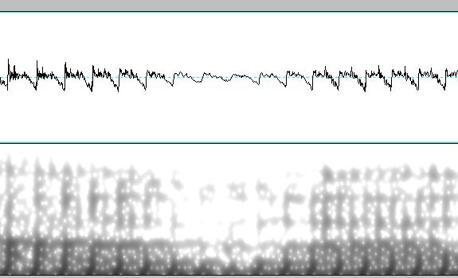
Figure 3: Wave form and spectrum for /aga/
Notice that the periodicity of the vowel /a/ and a fair bit of the formant structure was maintained during the fricative.
The VOT values do not provide reasonable clues to fully distinguish the three-way contrast, Table 5. Here both the lenis and fortis stops have short duration VOT, while aspirated stop has a significantly longer VOT.
Table 5: VOT values for word-medial /p/
VOT values for /apa/, /ap*a/, /apʰa/
lenis 0.0158 0.0178 0.0130 0.0263
fortis 0.0120 0.0130 0.0162 0.0130
aspirated 0.0403 0.0606 0.0522 0.0479
The f0 values for word-medial stops is similarly inconclusive, Table 6. For comparison sake, the f0 values for the same samples are provided.
Table 6: f0 values for word-initial /a/
f0 values for /apa/, /ap*a/, /apʰa/
lenis 97.74 105.84 108.27 98.46
fortis 103.34 114.11 94.44 112.28
aspirated 107.58 109.64 113.62 118.54
As one can see, the VOT and f0 do not provide sufficient to distinguish between the three-way stop contrast.
Han (1996) looked at closure as a means to distinguish between these stops. Cho (2002) found this closure time insufficient to distinguish the three varieties of stop, since the fortis and aspirated stops have similar closure times. Given the current data, this may prove to be sufficient, since the fortis and aspirated consonants can be distinguished based on VOT values, Table 7.
Table 7: Closure duration for word-medial /p/
VOT values for /apa/, /ap*a/, /apʰa/
lenis 00.0809 0.0684 0.0619 0.0766
fortis 00.1571 0.1397 0.2079 0.1084
aspirated 00.1287 0.1450 0.1131 0.1028
The data in this study indicates that a combination of VOT and f0 is sufficient to distinguish the three-way contrast in Korean stops in word-initial positions. In word-medial positions, the VOT and closure duration can be used to discriminate between this three-way contrast.
The alternation in the utility of f0 and closure time can be explained in terms of prosody and articulation. In word-initial positions (or more constituent-initial positions), Korean prosody allows phrasal pauses. They serve to help offset the grammatical particles (postposition) of Korean. Hence, closure time is not a reliable aural clue to distinguish between stop types. However, intonation (and hence f0) can easily be manipulated within this context, that is, following a prosodic pause. Within a word, however, f0 is more difficult to manipulate. However, closure duration is easily perceived. In fact, the lenition of the lenis velar stop can be explained as a further accentuation of the closure distinction.

References
Boersma, P & D Weenink (2006). Praat: doing phonetics by computer (Version 4.5.02) [Computer Program].
Cho, T, S-A Jun, & P Ladefoged (2002). Acoustic and aerodynamic correlates to Korean stops and fricatives. Journal of Phonetics, 30 (2), 193 – 228.
Choi, H (2002), Acoustic Cues for the Korean Stop Contrast – Dialectal variation. ZAS Papers in Linguistics 28, 1 – 12
Han, M. S. & R.S. Weitzman (1970)Acoustic features of Korean /P, T, K/, /p, t, k/ and /p^{h}, t^{h}, k^{h}/, Phonetica, 22, 112 – 128.
Han, J.-I. (1996) The phonetics and phonology of "tense" and "plain" consonants in Korean. PhD dissertation, Cornell University.
Kim, M-R, P.S. Beddor, & J. Horrocks (2002), The contribution of consonantal and vocalic information to the perception of Korean initial stops, Journal of Phonetics 30 (1), 77-100.
Mo Y, (2005), Acoustic study of Korean vowel devoicing depending on the preceding consonants and intrinsic/ extrinsic vowel durations, The 15th Japanese / Korean Linguistics Conference, University of Wisconsin – Madison.

Appendix A
Word list for the word-initial stops.
가다 까다 카키
다섯 따다 타다
바지 빵을 파랑
잡아 짜장 차다
고대 꽃이 코는
도체 똥개 통역
보다 뽐내 포고
졸아 쪽에 초석
기재 끼니 키가
디딤돌 띠다 티켓
비디오 삐다 피난
지지 찌개 치다
Word list for the word-medial stops.
나가 아까 박한
바다 받다 바탕
잡아 아빠 아파
맞아 가짜 아차
보고 녹고 얼어 좋고 나빠
고도 꽃도 고통
보보 일곱 보 모포
고조 missing 오 초
지기 익기 익히
비디오 허리띠 키티
시비 엄지 삐 잎이
지지 믿지 미치다

